Tab 1
Designing AI for the Disconnected: How Can We Make Disaster Information Truly Reach Everyone?
– Research question explanation –

Organization: Code for Korea

Background
In March 2025, a massive wildfire broke out along Korea's east coast, prompting the emergency evacuation of thousands of people. While alerts were issued, many elderly people, foreigners, and people with disabilities struggled to access and understand the critical information they needed.
- Korea’s deadly wildfires expose the grim reality of its dying rural areas (Apr 1 2025) https://english.hani.co.kr/arti/english_edition/e_national/1190073.html
“Many of the elderly residents don’t use smartphones, meaning that they don’t receive the flood of emergency disaster alerts sent out by the government. Most of them heard the news through the village foreman or the village broadcast. Some of them were carried out of their homes after falling asleep.
The March wildfires killed 26 people in North Gyeongsang alone. One was a helicopter pilot who died in a crash, and the remaining 25 were all local residents. By age group, two were in their 50s, seven in their 60s, two in their 70s, 13 in their 80s, and one in their 90s. That is, 16 of the deceased, or 64%, were in their 70s or older. “
- Emergency text alerts lack of information on evacuation fail to save elderly in rural areas from wildfires (Mar 27 2025) https://english.khan.co.kr/khan_art_view.html?artid=202503271812387&code=710100&eng&utm_source=khan_rss&utm_medium=rss&utm_campaign=english_news
“Disaster safety experts said the current emergency text alerts sent during disasters and emergencies are not effective for the elderly, disabled, and others. (…) “When you look at an emergency text alert, there is no information about support for the elderly and people with disabilities. They don't tell us who will help evacuate and how because they assume that we will evacuate on our own.” This means that generalized disaster guidance is of little help to the elderly, who may not be able to evacuate on their own.”
Existing mobile apps like the Emergency Ready App(For Foreign Residents in Korea. Play store/App store) or Anjeondidimdol 안전디딤돌 (For Korean Nationals. Play store/App store) distributed by the Ministry of the Interior and Safety, often present information that is too complex or text-heavy. Vulnerable groups—such as the elderly, persons with disabilities, children, and non-Korean speakers—are frequently left behind.
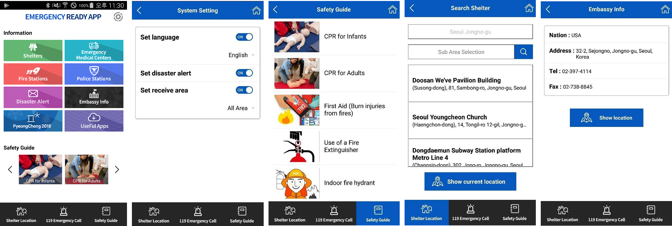
Screenshots of Emergency Ready
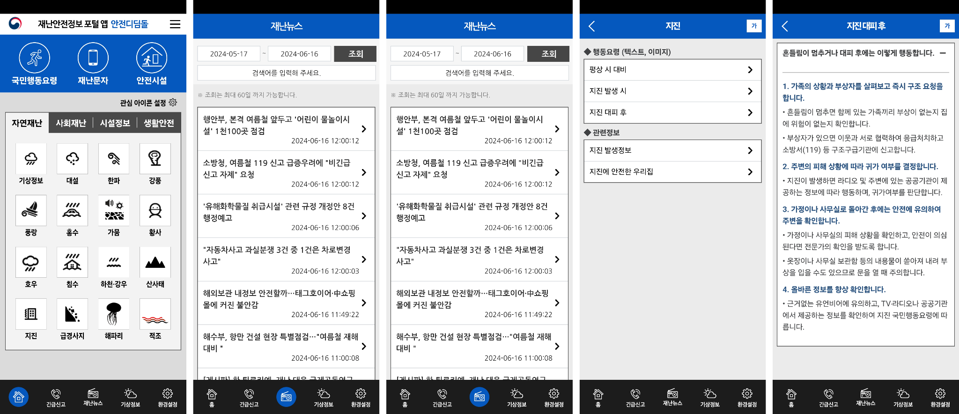
Screenshots of Anjeondidimdol 안전디딤돌

Recognizing these limitations, the Korean government is now actively working to improve disaster safety services using public data and AI. Notable examples include:
- Ulsan City’s GPT-powered disaster chatbot https://www.ulsanpress.net/news/articleView.html?idxno=519141 (Available in Korean only): An AI-based disaster information service currently under development by Ulsan City. The chatbot leverages GPT technology to help residents access real-time safety guidance, such as evacuation routes and shelter information, through natural-language interaction in Korean. The project aims to improve disaster communication using public data and conversational AI.
- Uljoo County’s Cloud-Based AI Safety Navigation System (Chatbot) https://govexpo.kr/exhibition/innovation/173 (Available in Korean only): Cloud-Based AI Safety Navigation Chatbot designed to deliver fast, accurate, and personalized safety information during disasters. The chatbot uses real-time location-based services to guide residents and tourists to nearby shelters and provide action steps, especially in cases like radiation emergencies. It was developed with a strong focus on digital inclusion, offering an intuitive interface for elderly users and those with limited digital literacy. The system runs on cloud infrastructure, ensuring scalability during high-traffic events, and is accessible across all smart devices including tablets and PCs.
- SQNT’s Cloud-based Disaster Safety Navigation System: SQNT has developed a cloud-based Disaster Safety Navigation System using the TIPA cloud platform as part of a national R&D project. The system enables real-time management of evacuees and relief supplies during disasters, allowing both public officials and residents to handle shelter admission, food, and medical support via mobile devices. Already adopted by Ulsan City and Yeonggwang County, and used in radiation drills in Busan and Yangsan, the system aims to reduce response delays and improve emergency shelter operations. SQNT also plans to launch a customized shelter guidance app tailored to different types of disasters such as typhoons, floods, and wildfires.

Problem Statement
While recent developments in AI-powered disaster services show great promise, they often overlook the needs of vulnerable populations—especially older adults, people with disabilities, and non-native speakers. During the 2025 wildfires in Korea, emergency text alerts failed to reach many elderly residents due to digital illiteracy, lack of smartphone access, or poor network connectivity. Without intentional consideration, future AI-driven systems risk replicating the same shortcomings, providing fast and intelligent services only to those already digitally connected—while leaving behind those who are most at risk.

Research Question
How might we leverage AI to enhance the accessibility and comprehension of disaster information (e.g., disaster alerts, shelter locations) for vulnerable populations, ultimately strengthening their disaster response capabilities?

Technical Resources
Participants may utilize public datasets from the Disaster Safety Data Sharing Platform, a national portal operated by the Ministry of the Interior and Safety. The platform provides access to both structured and unstructured data related to disaster and safety management.

Following is a step-by-step guide for participants on how to find datasets using the Disaster Safety Data Sharing Platform, including how to use Google Translate to navigate the Korean interface:
Disaster Safety Data Sharing Platform – User Guide (Available in Korean only) https://www.safetydata.go.kr/userGuide/intro

- Go to https://www.safetydata.go.kr . Account registration needed to download datasets or use the APIs.
- Activate Google translation for the page. In Chrome, right-click anywhere on the page and choose “Translate to English” or click the Google Translate icon in the URL bar if it appears. The page will automatically convert Korean text to English.
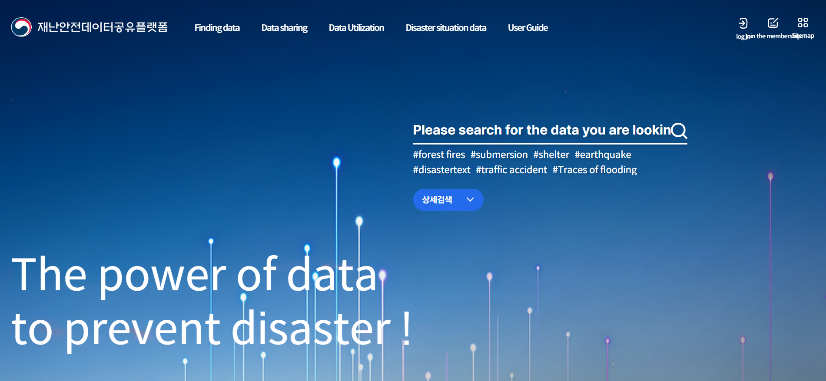

- Click on the popular keywords shown in the center of the homepage to explore trending datasets or Go to “Finding Data 데이터 찾기 > Data List 데이터 목록” from the top menu to browse and search datasets directly.

Please note: The search function on the Disaster Safety Data Sharing Platform only works with Korean keywords. If you're using English, be sure to activate Google Translate first, then search using the translated Korean terms (e.g., “태풍” for “typhoon”, “대피소” for “shelter”).

English Keyword | Korean (Search Term) | Example dataset
Earthquake | 지진 | Earthquake Notifications 지진 통보  https://www.safetydata.go.kr/disaster-data/view?dataSn=38
Wildfire | 산불 | Wildfire Information 산불 정보  https://www.safetydata.go.kr/disaster-data/view?dataSn=882
Flooded area | 침수지역 | Flood Trace Map 침수흔적도  https://www.safetydata.go.kr/disaster-data/view?dataSn=108
Shelter | 대피소 | Integrated Shelters 통합대피소  https://www.safetydata.go.kr/disaster-data/view?dataSn=1346
Disaster alert | 재난 문자 | Emergency Disaster Text Alerts 긴급재난문자  https://www.safetydata.go.kr/disaster-data/view?dataSn=228
Tsunami | 해일 | Emergency Evacuation Sites for Earthquake and Tsunami 지진해일 긴급대피장소  https://www.safetydata.go.kr/disaster-data/view?dataSn=1340
Landslide | 산사태 | Landslide Risk Prediction 산사태 발생 예측  https://www.safetydata.go.kr/disaster-data/view?dataSn=856
Fire | 화재 | Large-Scale Fire Incident Status 대형 화재 발생 현황  https://www.safetydata.go.kr/disaster-data/view?dataSn=3759
Elderly population | 고령자 | Elderly Population Statistics 고령인구수  https://www.safetydata.go.kr/disaster-data/view?dataSn=484

- Once you find a dataset you want to use, go to the dataset detail page and click the “Application for Use 이용신청 ” button in the top right corner.
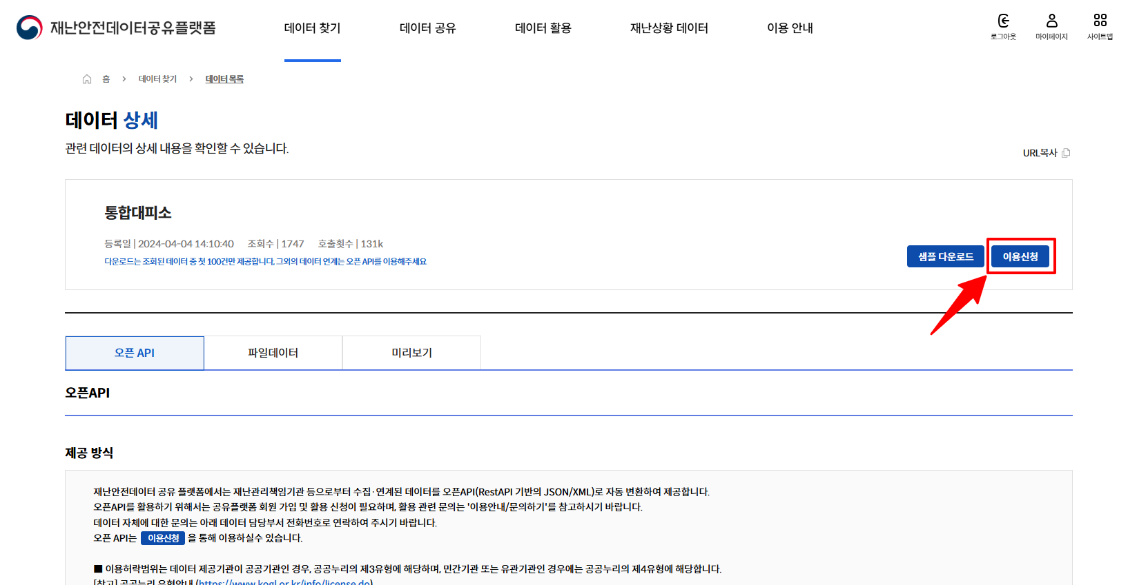

- Fill out the following: purpose of use, maximum number of calls per day, IP address, and scope of use agreement
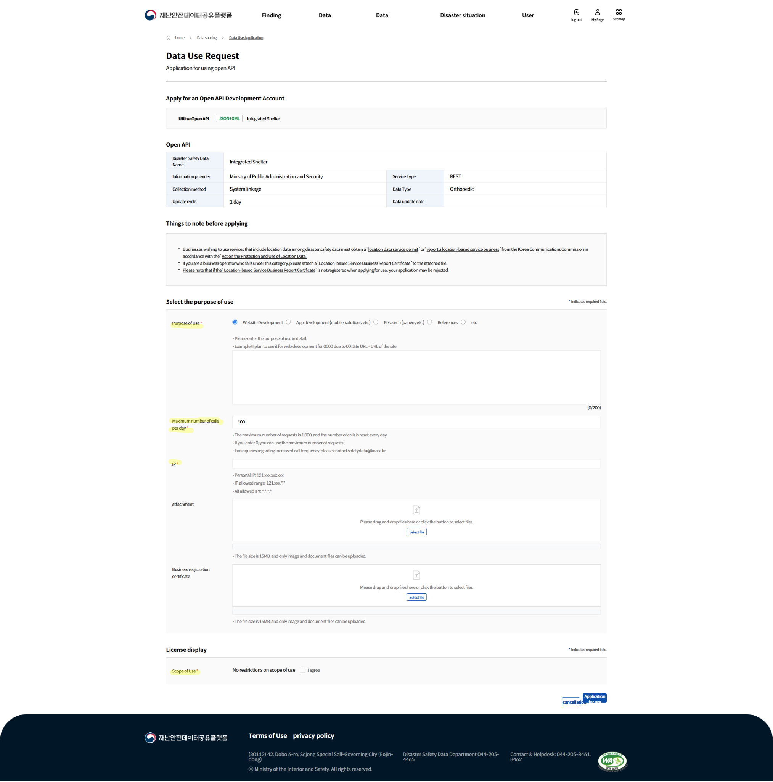

- Data will be available for use after the request is reviewed and approved. (takes about 5 mins)
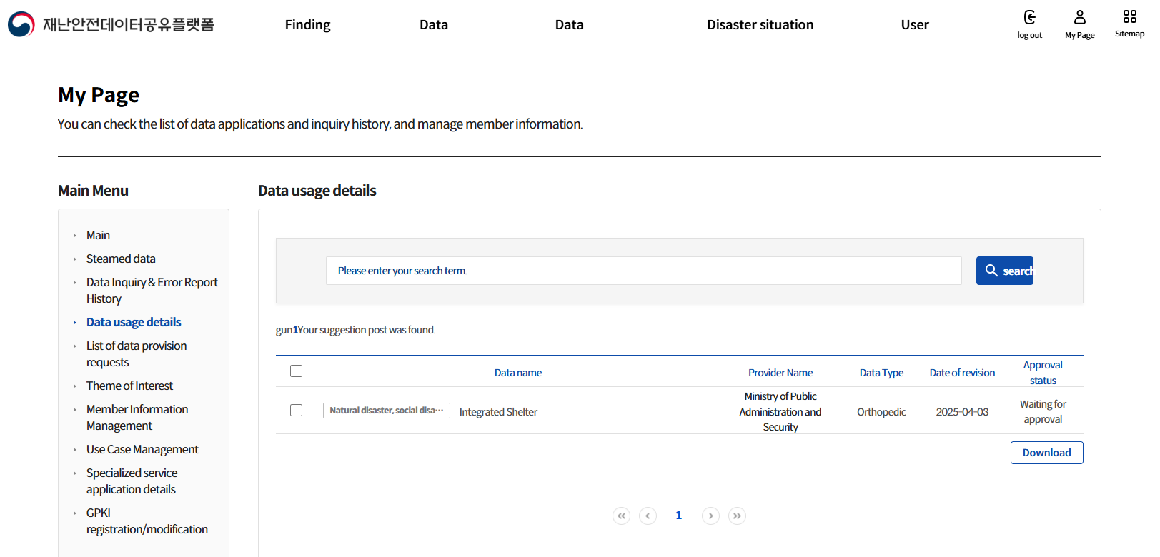

Deliverable
An MVP prototype of an AI-powered disaster information service that demonstrates how AI can be meaningfully applied to improve accessibility and comprehension for vulnerable populations.
Teams should also provide user scenarios that show how different types of users—such as elderly residents, non-Korean speakers, or people with disabilities—would interact with the service. Deliverables should showcase how AI can be responsibly applied to support disaster-vulnerable populations. Rather than building complex systems, teams are encouraged to design simple, inclusive services that apply AI in ways that improve clarity, accessibility, and responsiveness during disasters.

– E.O.D –

